# PSingleton_Module 4.2_CSD310 - 6/17/202

Screenshot of me connecting to the initial database that was created?

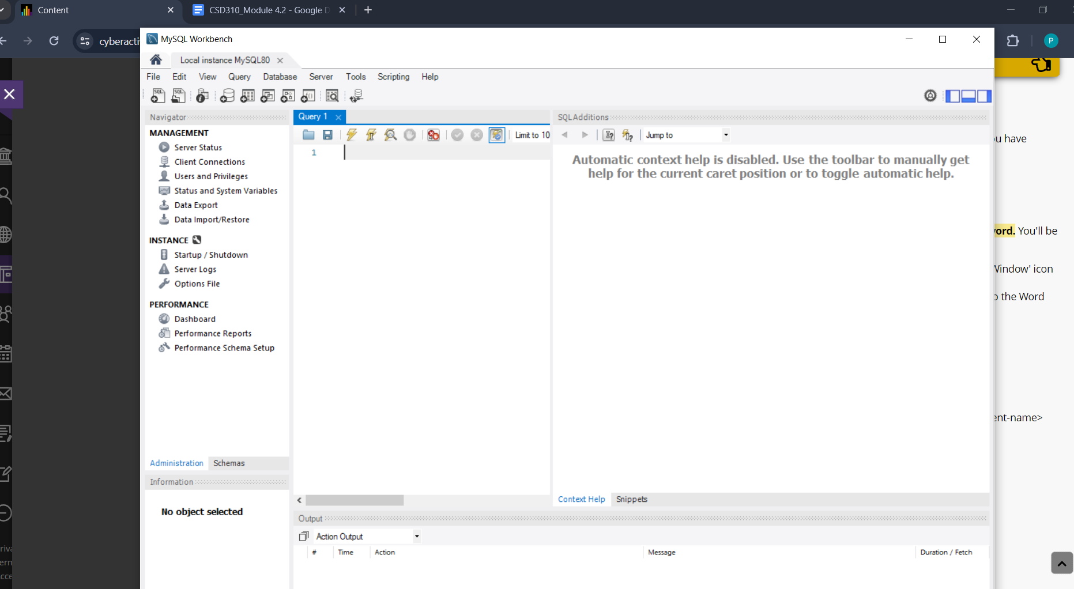

Screenshot of the database creation: (movies)

